Clinical Staff NST Workflow
- Open encounter for patient on the provider’s schedule.
- Room a patient like normal (collect: vitals, pharmacy, meds/allergies, review MA OB checklist, etc.).
- Go to the Fetal Testing 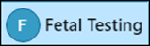 Activity.
- Click the pencil or New Reading 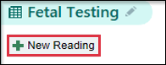
- Document your NST (extent of documentation is dependent on your clinical site). Support staff must at least add the clinical reason for the NST and the start/stop time if the patient is seeing a provider after the NST.
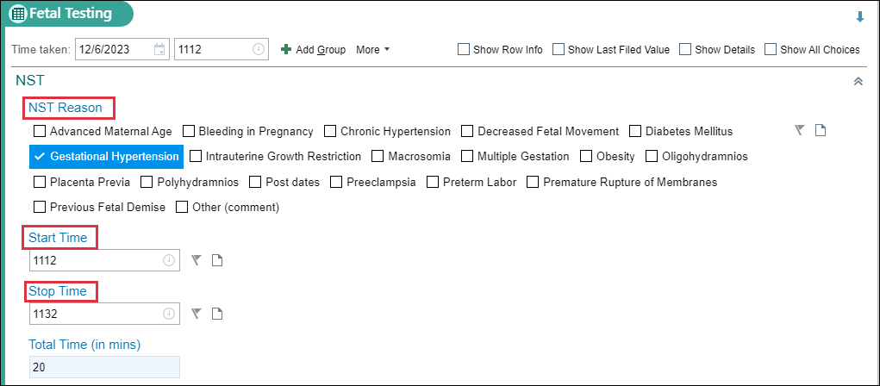
For NWP RNs, you’ll complete the additional documentation outlined in steps 6 and 7.

- Continue documenting the relevant information, including but not limited to baseline rate, variability, decelerations, accelerations, contractions, movements, use of acoustic stimulator (if applicable), and the corresponding results.
- NST Interventions: Document any interventions performed during the non-stress test, such as repositioning, administration of hydration, or notifying the provider.
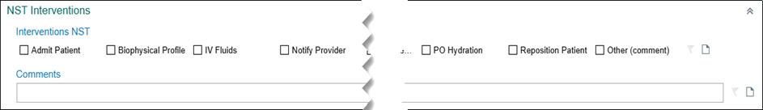

Notice that the documentation completed in the Fetal Testing activity automatically pulls into the OB note template.

*Note: each time you make changes to the Fetal Testing documentation, you may need to go back and refresh the Note template.*

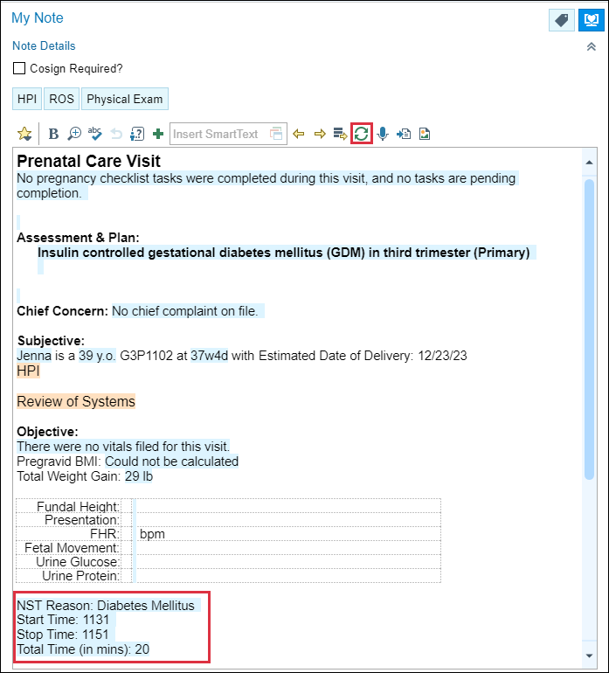

For trained support staff who complete documentation in all the fields of NSTs and patient does NOT have same day provider appointment, please remember to CC the chart to the provider when you are done with your documentation.

To CC a chart

- Go to the This Visit activity.
- Click on Follow-up using your navigation activities or scroll to Follow-up section.
- Locate Send Chart Upon Closing Workspace section,
- If this section is not visible, you may need to expand the section.
- Click the chevrons next to Show additional options.
- Add provider in the recipients’ box.
- Click Send Now.
